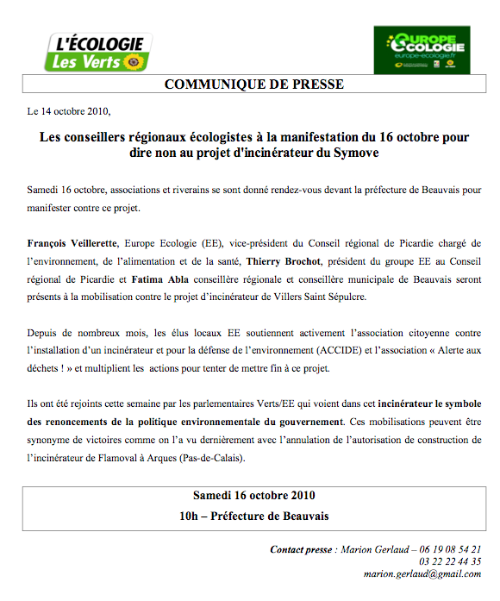

Contact presse

Marion Gerlaud
06.13.42.51.84

